Self-survey Individual completing survey: Date:
Site-survey Title:
Please type or print clearly. If this is a self-survey and requested information does not apply to your company, indicate N/A. Please return this form within 10 working days to the attention of the Kearfott individual who sent it.

Company Name: Phone No.:
Street Address: FAX No.:
City: State/Prov/County: Zip/Postal code:
Describe business ownership: Private Public
Describe business size (i.e: Large Business, Small Business):
Note: if “Small Business,” please see Small Business Size Self-Certification form: www.kearfott.com, Supplier Resources

Type of products or services rendered: Years in Business:
Organization | Name | Phone | Email | Reports to (Title)
President/General Manager
Quality Assurance Mgr.
Sales Manager
Is Company a Subsidiary of another company? If so, please include name and address:
Company Name: Phone No.:
Street Address: FAX No.:
City: State/Prov/County: Zip/Postal code:
List the names of two customers for whom the candidate supplier is an approved source
Customer Name: Customer Name:
Quality Management System Certifications held:
ISO9001 AS9100 FAA / EASA Other:
QMS Certified Suppliers are required to complete page 1.
Calibration Certifications held:
ISO/IEC 17025 A2LA ISO 10012
Calibration Certified suppliers are only required to complete page 1.
Calibration Process in accordance with:
ANSI/NCSL Z540-1 (Superseded by Z540.3) ANSI/NCSL Z540.3 (Superseded by 17025) ISO 17025
Calibration completed by OEM
Calibration Suppliers meeting the requirements of ANSI/NCSL Z540 (including Handbook) are only required to complete page 1.
Non- Certified Suppliers are required to complete pages 1 and 2.

If certified, please attach a copy of any certifications held.
If not certified please list with what quality system specifications the candidate supplier comply?
ACKNOWLEDGMENT
I hereby certify that the information contained herein is true and correct to the best of my knowledge, information and belief. I acknowledge that I have reviewed and understand Kearfott Supplier Resources located on Kearfott’s website: http://www.kearfott.com/support/supplier-resources/ Initial:
(Kearfott Use Only)
Supplier Status: Approved Conditionally Approved* Not Approved* Reviewed by: Date:
* Comments: Kearfott Supplier Code:
Risk Assessment:
Severity Score Occurrence Score Detection Score = Risk Priority Number (RPN)
RPN Over 29 shall require risk mitigation documentation (reference ASPP 1.2)
 |  | yes |  | no | Under  way | N/A
- CALIBRATION SYSTEM REQUIREMENTS
1 | There is a documented calibration control system  (Please forward a copy with this completed questionnaire).
2 | Documentation is coordinated with inspection/quality.
3 | Documentation includes listing of standards/measuring equipment which include nomenclature, part number, serial number, calibration interval, source, and calibration procedure.
4 | Documentation defines and implements adequate environmental control.
5 | Documentation defines labels, tags, forms, and decals utilized to control calibration.
6 | Standards utilized are of sufficient accuracy for intended use.
7 | Standards are traceable to NIST.
8 | Environmental control limits are established and maintained to the degree necessary to assure correct measurement.
9 | All standards and measuring equipment are assigned recall intervals.
10 | All historical records indicate standards and measuring equipment are periodically recalibrated to pre-established cycles.
11 | A system exists to establish and change recall intervals.
12 | A mandatory system for recall is operational.
13 | Written calibration procedures are provided and utilized for all calibrations.
14 | Out of tolerance findings are reported to equipment users, and disposition made as to the impact on product quality/test results.
15 | Certificates on file to verify traceability of calibration sources to National Standards.
16 | Certificates contain required data.
17 | Documentation of surveys of vendor subcontracted calibration sources are completed and available.
18 | Records are available for all calibration and services performed.
19 | Records are complete and include reports and or certificate numbers when applicable.
20 | Certifications have NIST traceability numbers and state conformance to ANSI/NCSL Z 540
21 | Calibration labels indicate date done, date due, and the name of the individual performing calibration.
22 | Items not calibrated to their full capability are properly labeled to indicate the applicable condition.
23 | Adequate handling facilities are available to assure that equipment is handled in a manner so as to not affect the calibration of standards and measuring equipment.

FORM INSTRUCTIONS

Kearfott Quality Assurance submits to Supplier for completion of Parts 1-6 and page 2 as required.
Supplier submits to Kearfott Quality Assurance for review and completion of Part 7. Completed surveys are kept on file with Kearfott Quality Assurance.

Self-survey Individual completing survey: Date:
Site-survey Title:
1
Please type or print clearly. If this is a self-survey and requested information does not apply to your company, indicate N/A. Please return this form within 10 working days to the attention of the Kearfott individual who sent it.
Company Name: Phone No.:
Street Address: FAX No.:
City: State/Prov/County: Zip/Postal code:
Describe business ownership (Private, Public, Large Business, Small Business, Disadvantaged Business Enterprise DBE, Women’s Business Enterprise WBE):
Type of products or services rendered: Years in Business:
Organization  2 | Name | Phone | Email | Reports to (Title)
President/General Manager
Quality Assurance Mgr.
Sales Manager
Is Company a Subsidiary of another company? If so, please include name and address:
3
Company Name: Phone No.:
Street Address: FAX No.:
City: State/Prov/County: Zip/Postal code:
List the names of two customers for whom the candidate supplier is an approved source
4
Customer Name: Customer Name:
Quality Management System Certifications held:
5
ISO9001 AS9100 FAA / EASA Other:
QMS Certified Suppliers are required to complete page 1.
Calibration Certifications held:
ISO/IEC 17025 A2LA ISO 10012
Calibration Certified suppliers are only required to complete page 1.
Calibration Process in accordance with:
ANSI/NCSL Z540.3
Calibration Suppliers meeting the requirements of ANSI/NCSL Z540.3 (including Handbook) are only required to complete page 1.
Non- Certified Suppliers are required to complete pages 1 and 2.
If certified, please attach a copy of any certifications held.
If not certified please list with what quality system specifications the candidate supplier comply?
ACKNOWLEDGMENT
I hereby certify that the information contained herein is true and correct to the best of my knowledge, information and belief. I acknowledge that I have reviewed and understand Kearfott Supplier Resources located on Kearfott’s website: http://www.kearfott.com/support/supplier-resources/ Initial:
6
(Kearfott Use Only)
7
Supplier Status: Approved Conditionally Approved* Not Approved* Reviewed by: Date:
* Comments: Kearfott Supplier Code:
Risk Assessment:
7
Severity Score______ Occurrence Score______ Detection Score______ = Risk Priority Number (RPN) ______
RPN Over 29 shall require risk mitigation documentation (reference ASPP 1.2)
 | yes | no | Under  way | N/A
- Calibration System Requirements
Page 2

Form Approval

Form Reviewer | Position | Approval Signature
Rachel Thompson  (Process Owner) | Manager, Quality Engineering
Jeff Ledford | Manager, Materials | 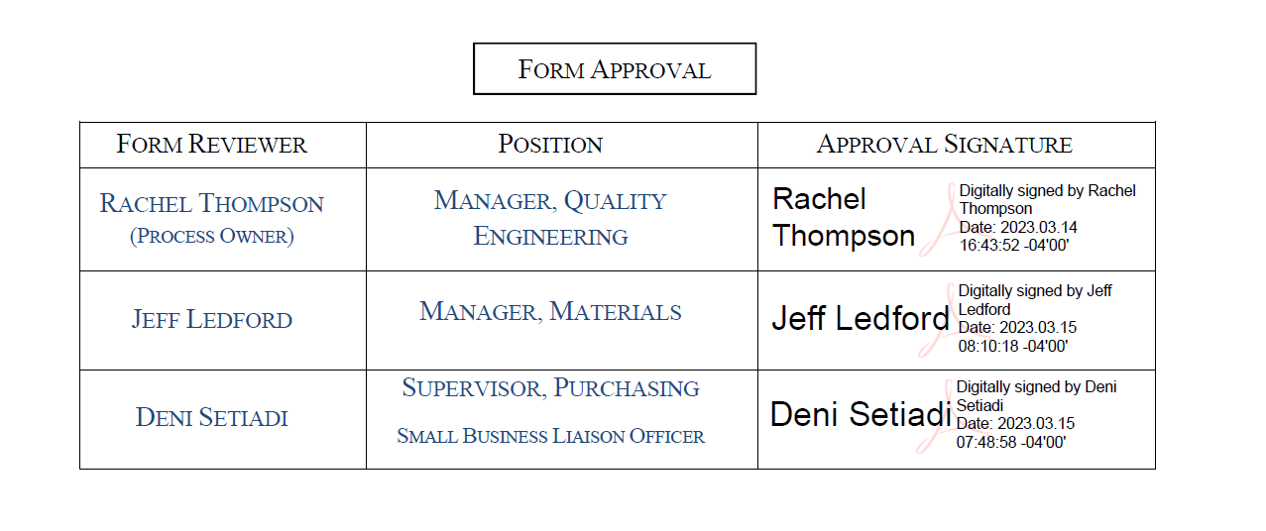
Deni Setiadi | Supervisor, Purchasing  Small Business Liaison Officer

Issue | Description | Date
1 | AS9100:D Initial Release | 02/16/18
2 | Calibration Certification Clarification | 03/07/18
3 | ANSI Z540.3 is NOT a Certification | 03/20/18
4 | Removed Vision requirements per ASQR-01 Rev 11 | 05/16/19
5 | Added ISO 17025 and OEM as calibration process | 11/3/2022
6 | Added Small Business Supplier note / Link; Re-formatted Business Size | 3/14/2023

