Self-survey Individual completing survey: Date:
Site-survey Title:
Please type or print clearly. If this is a self-survey and requested information does not apply to your company, indicate N/A. ISO/AS Certified suppliers and Consultants are only required to complete page 1. Non-Certified Suppliers are required to complete pages 1-3. Please return this form within 10 working days to the attention of the Kearfott individual who sent it.

Company Name: Phone No.:
Street Address: FAX No.:
City: State/Prov/County: Zip/Postal code:
Describe business ownership: Private Public
Describe business size (i.e: Large Business, Small Business):
Note: if “Small Business,” please see Small Business Size Self-Certification form: www.kearfott.com, Supplier Resources

Business is a : Consultant Manufacturer Distributor Other:
Type of products or services rendered: Years in Business:
Organization | Name | Phone | Email | Reports to (Title)
President/General Manager
Engineering Manager
Production Manager
Quality Assurance Mgr.
Sales Manager
Is Company a Subsidiary of another company? If so, please include name and address:
Company Name: Phone No.:
Street Address: FAX No.:
City: State/Prov/County: Zip/Postal code:
Plant Area (sq.ft.): No. of Buildings: No. of Shifts: Current Shop Capacity Used:
Total No. of No. of Mfg. No. of Eng'g No. of QA/QC No. of Admin.
Employees: Personnel: Personnel: Personnel: Personnel:
Union shop (If yes, when does current contract expire): Years at present location:
List the names of two customers for whom the candidate supplier is an approved source
Customer Name: Customer Name:
Candidate Supplier Overall On Time Delivery and Quality Rating
Certifications held:
ISO9001 AS9100 AS9120 NADCAP FAA / EASA
ISO/IEC 17025 ANSI/NCSL Z540.3 Other:
List Special Process certifications:
If certified, please attach a copy of any certifications held.
If not certified please list with what quality system specifications the candidate supplier comply?
ACKNOWLEDGMENT
I hereby certify that the information contained herein is true and correct to the best of my knowledge, information and belief. I acknowledge that I have reviewed and understand Kearfott Supplier Resources located on Kearfott’s website: http://www.kearfott.com/support/supplier-resources/ Initial:
(Kearfott Use Only)
Supplier Status: Approved Conditionally Approved* Not Approved* Reviewed by: Date:
* Comments:
Risk Assessment:
Severity Score______ Occurrence Score______ Detection Score______ = Risk Priority Number (RPN) ______
RPN Over 29 shall require risk mitigation documentation (reference ASPP 1.2)
 |  |  |  | yes |  |  | no | Under  way | N/A
quality assurance information
1 |  |  | The quality assurance organization's authorities and responsibilities are clearly defined in writing.
2 |  |  | The QA/QC Dept. has the authority to withhold items that have not met acceptable quality standards.
3 |  |  | There is a Quality System Manual defining the company’s QMS in detail.
4 |  |  | The company prepares and issues periodic reports and maintains records relative to item acceptance/rejection, and disposition of rejected items.
5 |  |  | The quality assurance organization maintains a system for the use and control of inspection stamps.
6 |  |  | The quality assurance organization has a system for quality evaluations of potential suppliers.
7 |  |  | The quality assurance organization reviews all purchase orders.
receiving inspection
1 |  |  | Is each lot of material received subjected to receiving inspection?
2 |  |  | Inspectors are provided with adequate inspection instructions.
3 |  |  | Does a documentation system exist to trace lot of material received until lot is expended?
4 |  |  | Can evidence of receiving inspection acceptance be found in each lot of material as it moves through the manufacturing process?
5 |  |  | Drawings used by receiving inspection are legible and reflect the latest changes.
6 |  |  | Sampling inspection, when applicable is performed in compliance with established recognized standards.
in-process inspection
1 |  |  | Is there an in-process traveler or inspection record on each unit or lot?
2 |  |  | Do manufacturing and quality personnel annotate the traveler for each operation performed?
3 |  |  | Adequate inspection instructions are made available to all in-process inspection personnel?
4 |  |  | Drawings used by inspection are legible and reflect the latest changes.
5 |  |  | The measuring devices, gauges and test equipment required for in-process inspection are available and are adequate.
6 |  |  | Sampling inspection, when applicable, is performed in compliance with established, recognized standards.
7 |  |  | The supplier maintains a system for the proper identification of the inspection status of in-process materials.
MEASURING DEVICES AND TEST EQUIPMENT
1 | Whenever measuring devices, gauges or test equipment items are reworked, they are inspected and calibrated prior to use.
2 |  | When new measuring devices, gauges and test equipment are acquired, they are inspected and calibrated prior to use.
3 |  | The processes for calibrating measuring devices, gauges and test equipment are covered by written procedures.
4 |  | All measuring devices, gauges and test equipment carry stamps which indicate the most recent calibration date and the date when the next calibration is to be performed.
5 |  | The supplier's quality assurance organization maintains a system for the automatic recall and periodic recalibration of all measuring devices, gauges and test equipment.
6 |  | Are calibration certificates with NIST traceability on file for all tools or calibration standards?
CONTROL OF NONCONFORMING PRODUCT
1 |  | The supplier maintains a documented system for handling of nonconforming materials
2 |  | The supplier maintains a system for removing nonconforming supplies from the product flow.
3 |  | The supplier maintains a system for taking corrective action in order to prevent repetitive discrepancies.
4 |  | The supplier maintains a system for following up on all corrective action requests.
5 |  | Reports on nonconforming materials are regularly prepared and are reviewed by management for action.
FINAL INSPECTION
1 |  | Adequate inspection instructions are available to final inspection personnel.
2 |  | Written instructions and procedures are readily available to all final inspection personnel.
3 |  | Drawings used by final inspection are legible and reflect the latest changes.
4 |  | The measuring devices, gauges and test equipment required for final inspection are available and adequate.
5 |  | Sampling inspection, when applicable, is performed in compliance with established, recognized standards.
SHIPPING AND PACKAGING
1 |  | The supplier's quality assurance organization operates a shipping inspection function.
2 |  | All shipping inspection operations are performed in accordance with written instructions.
3 |  | Shipping inspectors have ready access to customer specified packaging instructions.
4 |  | When required, certified packaging materials are used.

FORM INSTRUCTIONS
Self-survey Individual completing survey: Date:
Site-survey Title:
1
Please type or print clearly. If this is a self-survey and requested information does not apply to your company, indicate N/A. ISO/AS Certified suppliers and Consultants are only required to complete page 1. Non-Certified Suppliers are required to complete pages 1-3. Please return this form within 10 working days to the attention of the Kearfott individual who sent it.
Kearfott Quality Assurance submits to Supplier for completion of Parts 1-6 and pages 2-3 as required above. Supplier submits to Kearfott Quality Assurance for review and completion of Part 7. Completed surveys are kept on file with Kearfott Quality Assurance.

Company Name: Phone No.:
Street Address: FAX No.:
City: State/Prov/County: Zip/Postal code:
Describe business ownership (Private, Public, Large Business, Small Business, Disadvantaged Business Enterprise DBE, Women’s Business Enterprise WBE):
Business is a : Consultant Manufacturer Distributor Other:
Type of products or services rendered: Years in Business:
Organization  2 | Name | Phone | Email | Reports to (Title)
President/General Manager
Engineering Manager
Production Manager
Quality Assurance Mgr.
Sales Manager
Is Company a Subsidiary of another company? If so, please include name and address:
Company Name: Phone No.:
Street Address: FAX No.:
City: State/Prov/County: Zip/Postal code:
Plant Area (sq.ft.): No. of Buildings: No. of Shifts: Current Shop Capacity Used:
Total No. of No. of Mfg. No. of Eng'g No. of QA/QC No. of Admin.
3
Employees: Personnel: Personnel: Personnel: Personnel:
Union shop (If yes, when does current contract expire): Years at present location:
List the names of two customers for whom the candidate supplier is an approved source
4
Customer Name: Customer Name:
Candidate Supplier Overall On Time Delivery and Quality Rating
Certifications held:
ISO9001 AS9100 AS9120 NADCAP FAA / EASA
5
ISO/IEC 17025 ANSI/NCSL Z540.3 Other:
List Special Process certifications:
If certified, please attach a copy of any certifications held.
If not certified please list with what quality system specifications the candidate supplier comply?
ACKNOWLEDGMENT
I hereby certify that the information contained herein is true and correct to the best of my knowledge, information and belief. I acknowledge that I have reviewed and understand Kearfott Supplier Resources located on Kearfott’s website: http://www.kearfott.com/support/supplier-resources/ Initial:
6
(Kearfott Use Only)
7
Supplier Status: Approved Conditionally Approved* Not Approved* Reviewed by: Date:
* Comments:
Risk Assessment:
7
Severity Score______ Occurrence Score______ Detection Score______ = Risk Priority Number (RPN) ______
RPN Over 29 shall require risk mitigation documentation (reference ASPP 1.2)
 | yes | no | Under  way | N/A
quality assurance information
Pages 2-3

Form Approval

Form Reviewer | Position | Approval Signature
Rachel Thompson  (Process Owner) | Manager, Quality Engineering
Jeff Ledford | Manager, Materials | 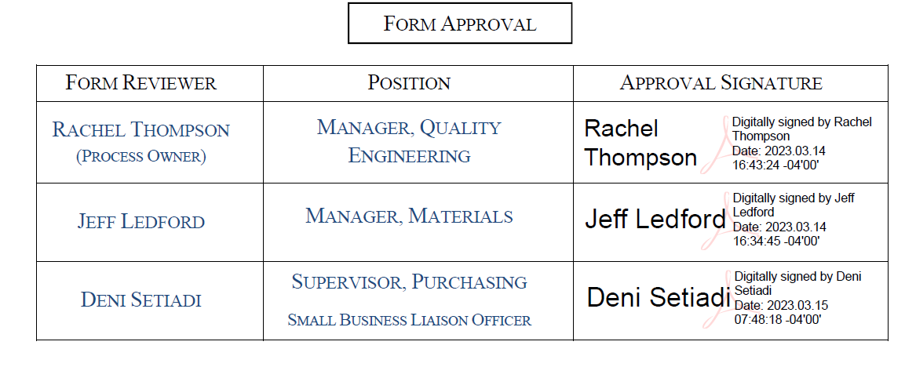
Deni Setiadi | Supervisor, Purchasing  Small Business Liaison Officer

Issue | Description | Date
1 | AS9100:D Initial Release | 02/16/18
2 | Added Small Business Supplier note / Link; Re-formatted Business Size | 3/14/2023

